UNIT –I

- Answer the following:
  - Define the following: (i) Resistance (ii) Conductance
  - State Ohm’s Law? Also write the limitations of Ohm’s Law?
  - Define the following: (a) Power (b) Energy
  - Define the following: (a) Inductance (b) Capacitance
  - State Kirchoff’s Laws?
  - Define Mesh and Super mesh
  - Define Node and Super Node
  - Define active and passive elements.
  - Define lumped and distributed network
  - Define bilateral and unilateral network.
  - Define linear and non-linear network.
- Derive the expression for Delta connected resistances in terms of Star connected resistances?
- What are the types of sources? Explain them with suitable diagrams and Characteristics?
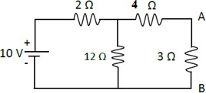
- Find the current in the 3Ω resistor in the network shown in figure (1)
Fig. (1)
- Derive an expression for total resistance when three resistances R_{1,} R₂ & R₃ are connected in Parallel?
- Find the equivalent resistance across the terminals A and B of the network shown in fig (2) using Star-delta transformation.
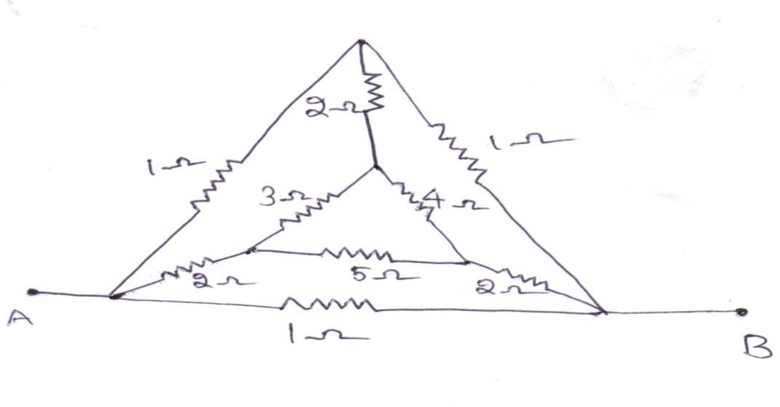
Fig. (2)

- Find the current passing through each resistor for the circuit below in fig (3).
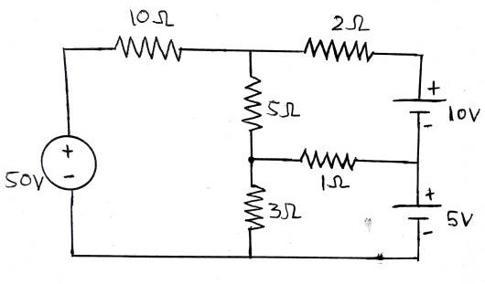
Fig. (3)
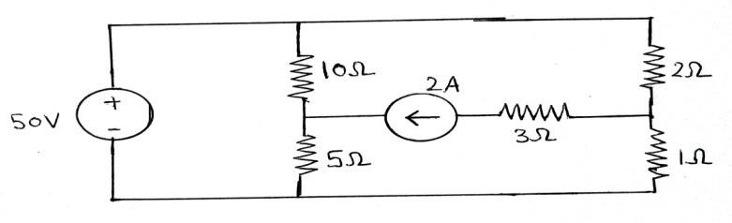
- Determine the current in the 5Ω resistor in the network given in figure (4).
Fig. (4)

- Determine the voltages at each node for the circuit shown in figure (5).
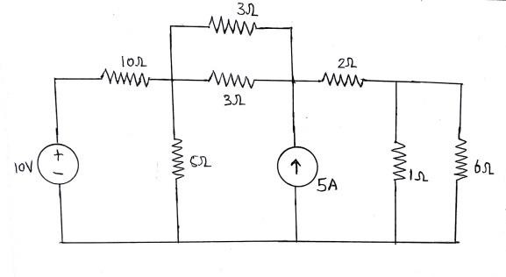
Fig. (5)
- Determine the current in the 5Ω resistor in the network given in figure (6).

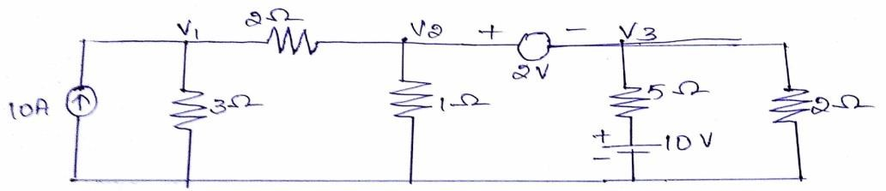
Fig. (6)
- Write the node equations by inspection method for the circuit shown below in figure (7).

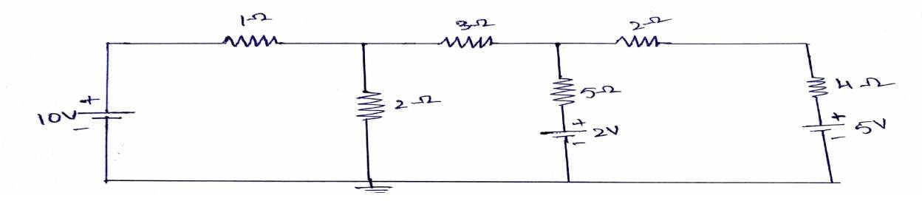
Fig. (7)

12. a) Explain about Nodal analysis and write the steps for applying nodal analysis.
b) Determine the mesh currents for the following network.
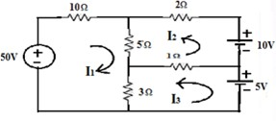
- a) Explain about Mesh analysis and write the steps for writing mesh analysis.
b) Determine the current in 10Ω resistor for the following network by using nodal analysis.
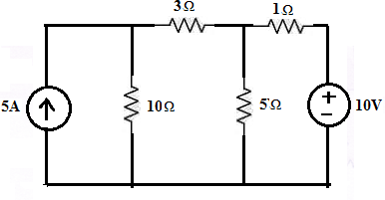
14.a) Determine i_{x} for the following network.
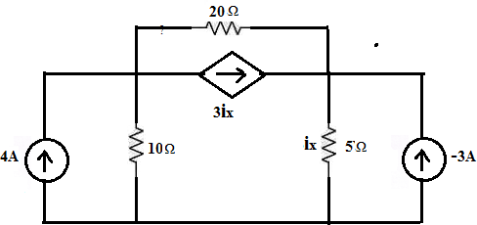

- b) Determine the equivalent current source between the terminals A and B using source transformation.
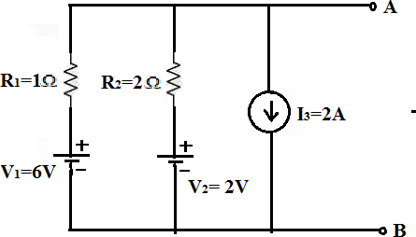

. 15. Find the current across the 7kΩ resistor in the circuit shown in following figure

